**LITERATURE REVIEW**

**2.1 Introduction**

This section gives a summary of the relevant research on climate change and crop cultivation that has been done before. The study focuses its attention on the two primary aspects of this body of research: the effect that climate change will have on rice cultivation and the ways in which farmers will adapt to it. The following is an outline of how this chapter is structured. In the next section, we will take a cursory look at climate change on a worldwide scale. The relationship between shifts in the weather and alterations in agricultural yield is discussed in Section 2.3. The many models that were used in the analysis of the effects of climate change on crop cultivation are evaluated in Section 2.4. In Section 2.5, a review is given of the empirical research that has been conducted on the effects of climate change on crop cultivation in Bangladesh. This section explains all there is to know about Aus, Aman, and Boro rice, as well as the influence that season shifting has on these types of rice. In Section 2.7, we address the voids and weak points that exist in the current body of research.

**2.2 Evidence of global climate change**

The long-term weather conditions throughout the world are changing as a direct effect of climate change. To be more specific, the term "climate change" refers to a major statistical fluctuation that lasts for lengthy periods of time, generally decades or more. This fluctuation might take place either in the average state of the climate or in its fluctuation (Vijaya Venkata Raman et al. 2011). The effects of climate change, which include but are not limited to rising sea levels, melting snow and ice, and shifting weather patterns, have already been detected as a direct result of human activity, such as the combustion of fossil fuels.

The Intergovernmental Panel on Climate Change (IPCC) published substantial evidence for fast climate change in 2007; they include:

1. The majority of this heating has actually occurred since the 1970s, with the 20 warmest years having taken place since 1981. Furthermore, 10 of the hottest years have taken place in the previous 12 years, making this the warmest decade on record.
2. The area covered by Arctic sea ice as well as its depth have both significantly decreased during the last several decades.
3. The average height of the world's oceans has increased by around 17 centimeters during the previous century. The rate for the prior century is nearly two times higher than the rate for the most recent decade.

Figures 2.1–2.5 depict the rising pattern of carbon dioxide (CO2) emissions, Arctic sea ice, Carbon dioxide concentration, rising sea levels, and the average temperature of the earth's surface (Vijaya Venkata Raman et al. 2011).

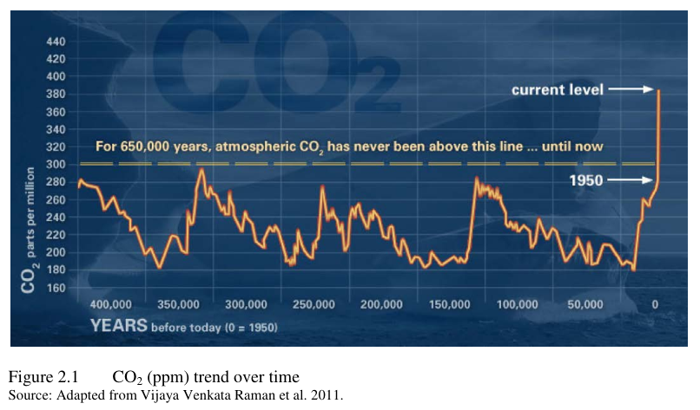

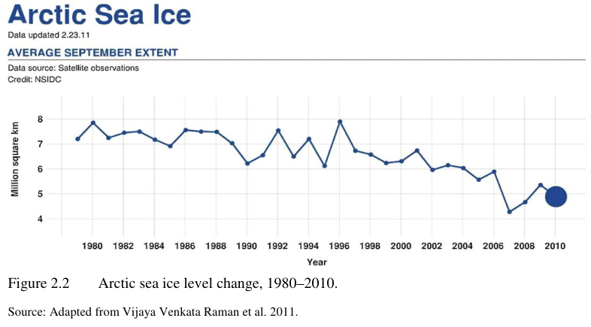

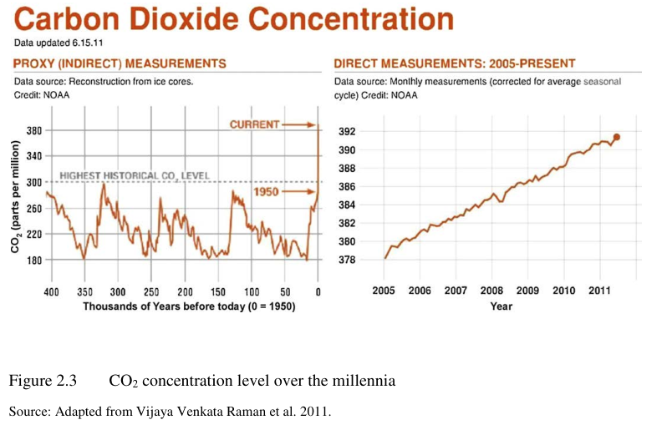

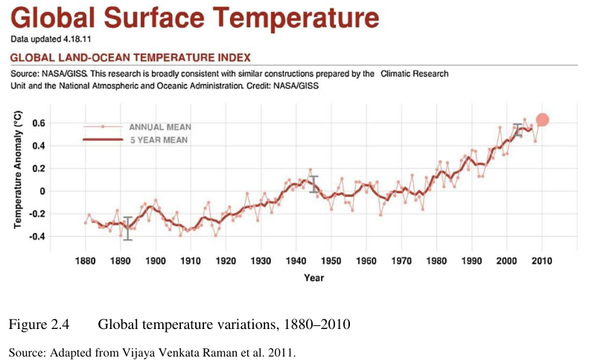

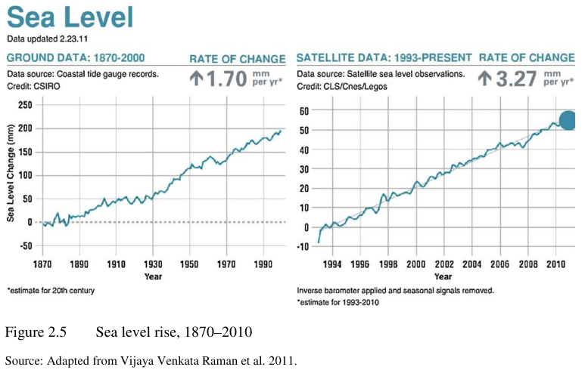

**2.3 Interplay of climate change, crop production**

It is anticipated that climate change will have a considerable influence on agricultural productivity throughout the world. This will take place due to the fact that agricultural production is extremely sensitive to climate and is negatively impacted by continuing to increase effects of global warming as well as climate variability (Smit et al. 2000; IPCC 2007; Chandrappa, et al. 2011). This will take place even though crop yields are highly sensitive to climate and is negatively influenced by escalating global climate change. Therefore, climate changes have a significant impact on the yield of crops. It is anticipated that climate change would lead to greater yields in warmer temperatures and lower yields at lower elevations as a result of its impact on the world's global food supply chain. This immense stress comes from climate change (IPCC 2007).

According to a large body of research (Rosenzweig & Parry 1994; Parry et al. 1999; Reilly et al. 1999; Gregory et al. 2005), extreme heat, differential rainfall, river flooding, water shortages, and tropical storms would lead to a major decrease in global food production. This would be particularly true in developing countries (Rosenzweig & Parry 1994; Parry et al. 1999). According to the findings of a number of recent researches, global climate change may also have a significant impact on the global allocation of food stocks in various regions of the globe (Gregory et al. 2005; Schmidhuber & Tubiello 2007).

**2.4 Empirical studies on climate change effects on crop agriculture**

In this part, the empirical studies that have been conducted on the subject of the financial implications of climate change on crop cultivation are discussed. On the basis of the existing body of research, the assessments may be broken down into three distinct categories: the influence on farming all over the globe, the agriculture of industrialized nations, and the farming of emerging countries.

**2.4.1 Evidence from world agriculture**

Rosenzweig and Parry (1994), Darwin et al. (1995), Rosenzweig and Parry (1999), and Parry and Parry (2004) are only few of the research that looked at the potential consequences of climate change on agricultural productivity throughout the globe.

Rosenzweig and Parry (1994) used a crop development simulation to conduct an analysis of the potential effects that climate change would have on the availability of food throughout the globe. The primary conclusion of the study is that there would be a moderate decrease in food production all over the world as a direct result of a doubling of the quantity of Carbon dioxide in the atmosphere. It was also discovered that affluent nations and underdeveloped countries are affected by climate change in distinct ways. The effects of climate change will be felt most acutely in low-latitude areas, particularly in poor countries. These nations will be forced to shoulder a disproportionate share of the world's burden. The results of calculations that tested the efficacy of various adaptive alternatives available to farmers revealed that these choices are only seldom beneficial in narrowing the gap between industrialized and developing nations.

According to Darwin et al(1995) .'s findings, global cereal output is not likely to be negatively impacted by climate change; rather, there is a high probability that production of non-grain crops would decrease. The ability of farmers to adapt in the face of climate change will be absolutely necessary for the continuation of crop production. Therefore, a significant shift in climate might result in a decrease in the GDP of the whole world.

Using the Hardly Centre Coupled Model (HadCM2) global climate change model, Parry et al. (1999) investigated the potential effects of climate change on agricultural yields, the availability of food throughout the globe, and the likelihood of people being hungry. The ramifications for agricultural yields are favorable for nations located in middle and high latitude regions (i.e., the developed world), but the impacts are detrimental for nations located in low latitude zones (i.e., the developing world, excluding China). It seemed as if the expenses of modification and the adequacy of water sources for irrigation were relevant elements for future investigation.

The researchers Parry et al. (2004) used the HadCM3 global environmental models to predict the influence that various climate change scenarios might have on food output, yield, and the likelihood of people going hungry. The findings of their study show that agricultural yields would decrease dramatically both locally and internationally as a consequence of the anticipated major warming of the planet. This will have an effect on agricultural production.

These studies have all come to the same conclusion, which is that it is very improbable that global grain output would be jeopardized due to climate change. However, despite the fact that the impacts of climate change on food yields are favorable for industrialized nations, same impacts are detrimental for poor nations.

**2.4.2 Evidence from developed countries’ agriculture**

Developed nations, notably the United States, were the central objective of the preliminary studies that were conducted on the consequences of climate change on farming. One line of investigation used the production function technique to anticipate the influence on agricultural output by using crop computational methods (Adams et al. 1989; Rosenzweig 1989; Adams et al. 1995; Kaiser et al. 1993). The majority of these research predict that agriculture in the United States would suffer significant losses as a result of climate change.

In spite of this, a recent study conducted by Lobell et al. (2007) found that the majority of California's harvests were only marginally impacted by the ongoing climate change.

Other research has estimated the effects of climate change on farming by using a Ricardian approach and using cross-sectional data (Mendelsohn et al. 1994; Reinsborough 2003; Weber & Hauer 2003; Schlenker et al. 2005; Lippert et al. 2009). These studies include: Mendelsohn et al. Mendelsohn et al. (1994) came to the conclusion that the agricultural sector of the United States may stand to gain from climate change.

According to the findings of this research, a 1% rise in agricultural Gross domestic product is expected in a scenario in which CO2 levels double. Weber and Hauer come to same conclusions on the agricultural sector in Canada (2003).

In addition, Reinsborough (2003) demonstrated that the effects of climate change on Canadian agriculture over the next three decades will be minimal. Schlenker et al. (2005) calculated that the negative consequences on agricultural revenues would amount to roughly $5.3 billion annually for the United States of America. Finally, Lippert et al. (2009) used data collected at the district level to predict certain gains that would accrue to German farming as a result of the ongoing climate change. Nevertheless, the findings of their modeling give some indication of losses that may occur over the long run when variations in temperature and rainfall will become more severe. The scientific community has come to the conclusion that the agriculture of industrialized nations will not be negatively impacted by climate change in the remaining years of the 21st century.

**2.4.3 Evidence from middle income and lower income countries**

Due to the obvious magnitude of the industry, the climatic vulnerability of the sector, and the position of emerging nations in the lower elevations of the planet, it is anticipated that crop farming in developing nations would be significantly affected (IPCC 2007; Mendelsohn 2009). Recent research (Lansigan et al. 2000; Chang 2002; Gbetibouo & Hassan 2005; Kurukulasuriya & Ajwad 2007; Mariara & Karanja 2007; Haim et al. 2008; Sanghi & Mendelsohn 2008; Deressa & Hassan 2009; Moula 2009; Wang et al. 2009) has investigated the financial consequences of climate change on food production in developing nations. In these investigations, the Ricardian model was used, with the exception of the research carried out by Lansigan et al. (2000), Chang (2002), and Haim et al. (2008), who relied on the production function method.

According to the findings of Lansigan et al. (2000), climatic variability is the factor that most probably has an impact on rice output in the Philippines. The impacts that temperature and precipitation are predicted to have on 60 various farming crops in Taiwan were monitored and analyzed by Chang (2002). According to the findings of this study, climate change has significant repercussions for the production of grain. The researchers found that farmers as a whole would only suffer minimally from the rise in temperature, but an increase in rainfall might be catastrophic.

Haim et al. (2008) made their prediction by using a HadCM3 model. They hypothesized that between the years 2070 and 2100, Israeli wheat output will be adversely impacted. On the other hand, watering and the use of fertilizer might potentially cut down on prospective output losses.

Gbetibouo and Hassan (2005) used data from the district level in order to evaluate the monetary consequences that changing climate has had on a wide array of crops in South Africa. According to the findings of this research, an increase in temperature has no impact on the net income of summer crops but has a negative impact on the net revenue of winter crops. Irrigation, on the other hand, has emerged as a viable and effective alternative measure to counteract the potentially disastrous impacts of climate change. Using data from individual districts, Sanghi and Mendelsohn (2008) demonstrated that the effects of climate change are projected to have a significant negative impact on Brazil and India by the year 2100.

Researchers Kurukulasuriya and Ajwad (2007) utilized data collected at the farm level to conduct a cross-sectional analysis in order to determine how the effects of climate change have shown themselves in terms of the profitability of small - scale farming in Sri Lanka. According to the findings of this research, the region of that nation that is characterized by its dry climate is likely to be the one that is most negatively affected. On the other hand, it's probable that wetter locations will benefit. Mariara and Karanja (2007) conducted research to evaluate the effects of climate change on grain output in Kenya over the long run. According to the findings of this research, hot weather temperatures result in decreased net income, but increasing wind chills lead to increased net agricultural profit, and this effect becomes more pronounced as rainfall levels rise. According to this research, some of the most important adaptation strategies are crop shading, crop variety, water saving, and irrigation. The fact that the study did not examine the long-term effects of climate change is the primary limitation of the research.

According to Deressa and Hassan (2009)'s research, climatic factors would have a substantial impact on Ethiopia's agricultural production. Based on the results of three different climatic situation simulations, this research forecasts that there will be a fall in the total income generated from agricultural sales between the years 2050 and 2100. Adaptation strategies, on the other hand, should be able to cut down on this income loss. Moula (2009) conducted yet another research in which he evaluated the effects of climate change on subsistence farming for Cameroon by utilizing data from fields throughout the whole country. According to the findings of this research, the income generated from crops is more responsive to precipitation than it is to temperature, and a greater temperature is determined to be negative to agricultural production. This research uncovered a number of adaptation methods; however, it did not investigate the extent to which farmers actually used these strategies.

Mendelsohn and colleagues (2009) used data from farm-level surveys to evaluate the impacts of climate change on Mexican agriculture. They discovered that the value of agricultural land was highly susceptible to climate change.

To be more precise, researchers discovered that higher temperatures lowered the value of land. Irrigated farms, on the other hand, will have lower profit margins than monsoon fields.

Wang et al. (2009) approximated the immediate effects of temperature and precipitation on crop total earnings including both monsoon and watered farms in China, and they found that climate change was innocuous for irrigated farms but harmful for monsoon farmlands. In other words, climate change was beneficial for irrigated farms but detrimental for monsoon farms. In addition, it has been discovered that greater temperatures have a negative influence, on average, on crop income, but the impact of increased rainfall has been found to be favorable, on average. However, the repercussions are not uniformly exclusive to any one place in China.

**2.5 Impact and adaptation studies for Bangladesh**

Many people consider Bangladesh to be amongst the nations that are most at risk from the effects of climate change. However, there have only been a handful of studies done on the effects that climate change would have on Bangladesh's agricultural sector (Mahmood 1997 & 1998; Paul 1998; Ali 1999; Rahman 1999; Rashid & Islam 2007). Numerical simulations and observational methods are the two primary classifications that these researches may be placed into.

**2.5.1 Simulation or modelling type studies**

Using the YIELD model, Mahmood (1997) was able to assess the impact that changes in temperature have on Boro rice cultivation in 12 main rice producing areas. According to the findings, the timing of planting seems to have a significant part in determining the outputs of Boro rice. According to the findings of this research, there is a link between falling temperatures and the duration of the early development phase that is non-linear, although that relationship is largely linear with regard to subsequent developmental stages. A higher temperature was shown to offer prolonged and more consistent thermal environment for the maturation period as well. Yields have decreased as a direct consequence of the rise in temperature as well as the increase in evaporation and transpiration.

The YIELD model and the CERES-RICE model were evaluated by Mahmood (1998) to see which one performed better when it came to predicting temperature rises and rice yields. According to the findings of this research, the CERES-RICE model's productivity predictions seemed to react more favorably to a moderate increase in temperature than those predicted by the YIELD model.

**2.5.2 Descriptive or policy type studies**

Paul (1998) demonstrated that the dryness that occurred in northwest Bangladesh in 1994–1995 had a detrimental impact on 15 different types of crops. The Aman rice harvest was the most severely impacted, since it is the most important crop in that area. In addition, wealthy farmers implemented adjustment strategies such as crop replacement, water management, gap filling, and mixed cropping of wheat and kaon (a local food crop), whereas less prosperous farmers were unable to implement any strategies because they lacked the financial resources to purchase irrigation equipment or seed. Nevertheless, this research did not attempt to provide an all-encompassing assessment of how the drought would affect rice output.

Ali (1999) investigated severe weather phenomena including cyclones, storm surges, coastal erosion, and the backwater effect. According to the findings of this research, the sea level increases in regions with increased salt and warmth. On the other hand, it did not attempt to assess the impact that temperature and rainfall have on the productivity and output of agriculture in coastal areas. A significant amount of farmland will be lost in Bangladesh, mostly as a consequence of coastal erosion. This research also suggested several adaptation strategies such as the building of embankments and storm bunkers, as well as the implementation of new crop species that are compatible to the climate of the area.

**2.6 Origin of Rice**

Rice is an essential food plant that belongs to the grass family Gramineae. It is commonly farmed in warm regions, particularly in East Asia, and produces seeds that may be cooked and eaten as food. The plant's name comes from the Sanskrit word for rice, "dhan." The term "Ouliz," which originally originated from the Ningpo dialect of ancient Chinese, evolved into "Oruz" in Arabic and "Oryza" in Greek, both of which eventually became "Ritz" and "Rice." It is unknown where the terms dhan and dhanya came from in the beginning. Rice has been cultivated since ancient times and continues to be the primary source of nutrition for many millions of people. Rice was first farmed in China and Japan around 10,000 years ago, with the support of their respective royal families. This crop has a greater adaptability and may be found growing anywhere from North Korea to South Australia and at elevations ranging from sea level to about 2,600 meters (Jumla, Nepal).

**2.6.1 Rice Plant**

Paddy, which is the fruit of the rice plant, contains the cumin seed. The growing plumage and radical evolve into a stem and root development, respectively, as the seed germinates. The stem is composed of nodes as well as internodes. The leaf develops from a bud at the node and is made up of a sheath and a blade that is somewhat lengthy. The very last leaf is called the flag leaf, and it is the one that carries the rice panicle, which is the very final internode. This has florets, also known as spikelet; typically, a single paddy is produced by each flower.

Tillers are produced by basal nodes, which are responsible for the production of panicles. In compared to the conventional kinds, high-yielding varieties (HYVs) generate a greater number of tillers and grains, resulting in increased crop yields. Each of the several kinds of rice that are grown in Bangladesh has its own set of physio-genetic traits. Rayda, the group that gave rise to all of the other rice groups in Bangladesh, is today considered a vulnerable subgroup. There are numerous different types and land-races of rice, which are collectively referred to as germplasms. The Bangladesh Rice Research Institute (BRRI) has around 5,000 germplasms like these available for use in its gene bank.

**2.6.2 Rice and Its Forms**

Rice and rice products in a variety of forms, including processed rice and rice-based goods, are eaten in Bangladesh. The following describe each of these: Atap milled rice is made from sun-dried paddy, whereas Shiddhya-chaul milled rice is made from partially cooked paddy. Cheeda, khoi, and moodi are goods made from paddy that have been squashed, popped, or burst.

Paddy or carbohydrate is utilized in the production of a variety of products, including alcoholic drinks, cosmetics, and cigarette papers. Rice bran is processed into an edible oil as well as vitamins, and it is also used as feed for livestock and fowl. Rice husk, which is rich in silica, is ground up and used as a sandpaper in the process of cleaning gun barrels. The production of microchips for electrical devices requires pure silica, which may be produced from rice husk. Rice straw is used in a variety of ways, including as livestock feed, in the thatching of roofs, and in the production of straw boards.

Rice has a significant amount of carbohydrates. Approximately 8.5% of the total is comprised of protein. The rice diet is deficient in vitamins C and A. The amount of thiamin and riboflavin present is 0.27 micrograms and 0.12 micrograms, respectively.

**2.6.3 Rice Available in Bangladesh**

Rice is classified as a member of the family Gramineae and the tribe Oryzeae within that family. There is a possibility that either O. perennis or O. rufipogon was the father of Oryza sativa, also known as the Asian rice, which comprises all of the rice that is now grown. Rice has a total of 24 chromosomes, making up its 2n number. The O. officinalis species of wild rice may also be found in Bangladesh. In parts of the coast that are characterized by salinity and estuary conditions, a kind of wild rice known locally as Uri-Dhan may be found. Porteresia coarctata is the new name for the species that was formerly known as Oryza coarctata. Wild rice like this is a delight among the people who live along the shore and is picked by hand. It is not yet ready for mass manufacturing and requires further development.

Rice investigation has been conducted out at the Bangladesh Rice Research Institute (BRRI) since its founding in 1970 in the city of Gazipur, which is located 36 kilometers outside of the capital city of Dhaka. There are now 57 high-yielding rice cultivars that have been produced by the institution. Rice output has expanded by more than three times since the benchmark production of around 10 million tons in 1970-1971. Rice production is now at an all-time high. [SM Hasanuzzaman and Jahangir Alam]

**2.6.4 Deepwater Rice**

Deepwater rice that has been cultivated in water that is at least 50 centimeters deep for a duration of one month or more throughout the growth season. There are two varieties of these, distinguished by their size and the depth of the water: I The more common short version, and ii) Floating rice.

**2.6.4.1.a Traditional Tall Deepwater Rice**

Rice that floats is cultivated in water that is at least 100 centimeters deep, while traditional tall varieties have shorter leaves and are planted in water that is between 50 and 100 centimeters deep. The majority of the rice that is cultivated in Bangladesh during the rainy season is of the hovering variety. This type of rice is sometimes referred to as deep-water rice, although it is more often referred to by its local names, such as jolidhan, poushdhan, and so on.

**2.6.4.1.b Floating Deepwater Rice**

Deepwater (floating) paddy has three unique adjustments: (i) the capacity to grow longer as the water level rises; (ii) the capacity to build nodal plantlets and roots from the upper nodes in the water; and (iii) the upward flexing of the terminal portion of the plant known as the that keeps the breeding leaves and stems above the water as the flood water recedes.

**2.6.5 Rice Harvesting and threshing**

The crop is harvested as soon as it is ready to ensure that it does not decay or get damaged by the elements or pests. Because various sorts of rice mature at various periods throughout the year, it is possible to start harvesting certain varieties even while others are still growing to their full potential. Rice is harvested in Bangladesh over the following months according to the distinct seasons: July and August for Aus, November and December for broadcast Aman, November and January for transplanted Aman, April and May for local Boro, and for high yielding Boro (May-June).

The whole of the time span pertaining to Boro rice is shown in the following diagram:

May

April

March

February

January

November

December

Store Paddy

Reap Paddy

Irrigation

Removal of weeds

Plant seedlings

Make the land ready

Seed Sowing

The duration of production for Aus rice is shown in the following diagram:

September

August

July

June

May

March

April

Reap & Store Paddy

Removal of weeds

Removal of weeds

Plant seedlings

Seed sowing

Make the land ready

The full span of time for the cultivation of Aman rice is depicted in the following diagram:

December

November

October

September

August

June

July

Store Paddy

Reap Paddy

Irrigation

Removal of weeds

Removal of weeds

Plant seedlings

Seed Sowing

There are many timetables for the harvesting of different varieties of rice, and rice cannot be picked outside of its allotted period. Shifting of the seasons may have a significant effect on the amount of rice produced. The pattern of the rainfall allows us to notice the changing of the seasons. Rain that falls at the wrong time may ruin the crops, while rain that falls at the appropriate moment can bless them. Because of this, we need to take into consideration the season changing pattern in order to get the most out of our rice harvest while minimizing any losses.

**2.6.5 Effect of Season shifting on Rice Harvesting**

The consequences of a climate changes are already being seen throughout the nation, and they vary from place to place. For example, temperatures have increased throughout the periods, growing seasons have become longer, trends of rainfall have shifted, and heavy rainfall have increased in occurrence and intensity. Production of rice and profitability are both susceptible to large direct and indirect effects from the aforementioned factors. This is due to the fact that agriculture is highly dependent on the weather and climatic conditions.

1. Because of shifting rainfall trends and alterations in the accessibility of irrigation, heat will continue to rise, Carbon dioxide levels will continue to rise, and the amount of water that is available will become more erratic. These elements have an influence on the development and yield of plants as well as the environmental factors for the reproduction of animals.
2. If the periodicity of monsoon shifts, it might lead to an abundance of water during the shoulder seasons and a shortage of water during the most important growing times for crops.
3. The extending of the growth season will also result in several generations of insects being produced by the same species during each growing season, leading to an increase in the total number of generations produced each year. This may lead to pests acquiring a stronger counteraction to pesticides, in addition to increasing the number of insects that are already present in the atmosphere.

**2.7 Gaps or weaknesses in the existing literature**

This analysis of the previously published material has brought to light a few holes or deficiencies. The chapter provided an overview of the particular omissions. The following is a summary of the general deficiencies:

1. Studies conducted in the past on the effect that climate change has on agriculture focused on agriculture in industrialized nations, which revealed that these countries are not negatively impacted. Recent years have seen a rise in the number of scant studies conducted on the agriculture of emerging nations. The findings, on the other hand, do not all conform to the same pattern due to the fact that various agricultural methods, geological features, and technical levels were used. In addition, the majority of these early studies have made very few or no assumptions on adaptation and have instead concentrated solely on the potential effects of climate change on agricultural production.
2. Rice has not been the primary focus of any of the earlier research that employed time series data. In addition, the findings from those research were not reliable since there were not enough analytical and diagnostic testing performed.
3. Previous research using cross-sectional time series have not been conducted for a variety of rice production, hence there are relatively few of them.
4. There are various simulation studies pertaining to Bangladesh; however, there are no empirical research that make use of the conventional econometric methodology.